Year 3 and 4 Reading Top Tips
How parents can help …  - Give reading importance by reading together daily, let them see you read as well!  - Don’t let them struggle on words for too long, help by sounding it out or move on and work it out together  - Take it in turns to read, this helps build a love of longer books which can seem daunting  - Read a range of texts - reading is reading!  - Praise them for trying.  - Use questioning but don’t ruin the flow of the story | Reading for Pleasure  Make it fun ..  - Talk about the story as you go along  - Recap before you start and summarise when you have finished  - Visit the library and borrow books to read together  - Read items in everyday life: menus, signs, recipes, newspapers, (TV/films)  - Try factual books and comics or magazines
Key Skills  - I can find and retrieve information from within a text  - I can infer and deduce information, events or ideas from a text  - I can explain the structure and organisation of the text  - I can explain and comment on the author’s use of language  - I can identify and comment of the writers’ purposes and viewpoints and overall effect of the text on the reader | 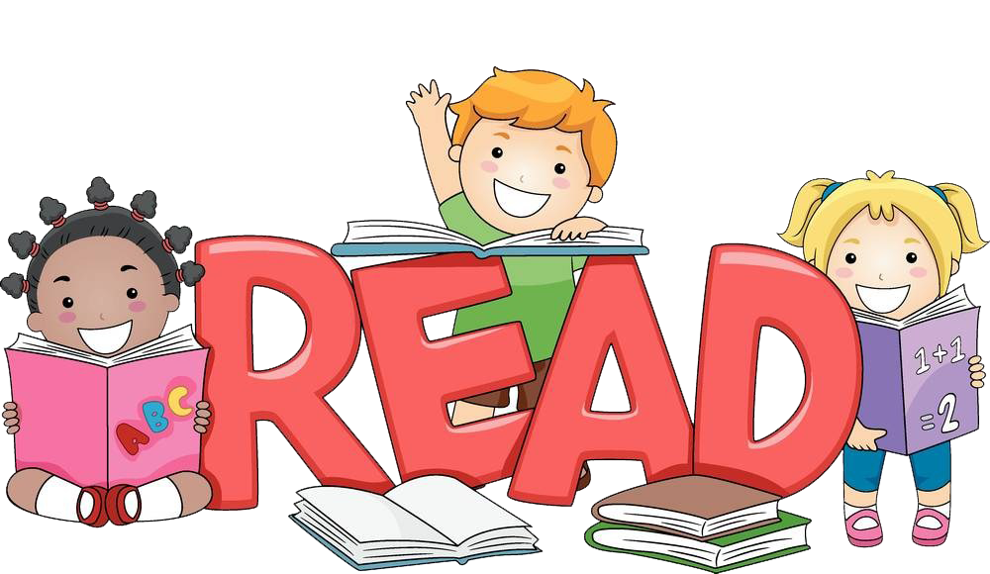
Talk about the text...  Who/What/When?  Where/Why/How?  What/Why do you think…. ? What makes you think that?  How do you know …. is feeling ….? | Model  Children love to do as adults do, show them you enjoy reading too.  Why not take a book from the Highlees Book Swap, there are lots of books, suitable for all tastes.  Books are free but donations are welcome!  